Fltterning json data 7

Dataset 7= emp_details_6

[

{

"id":"101",

"name":"srinivas",

"gender":"male",

"languages":["English","Hindi"]

},

{

"id":"102",

"name":"phani",

"gender":"male",

"languages":["English","Hindi"]

}

]

Here array of values provided in single column

1. Add source similarly as previous one

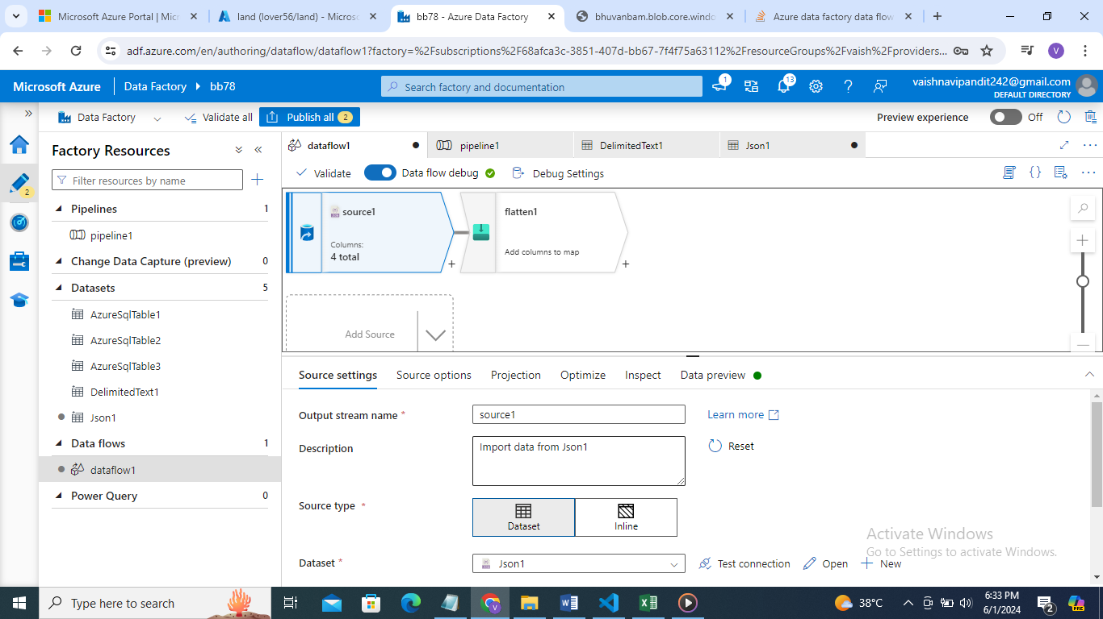

1. Now click on + and select flattern

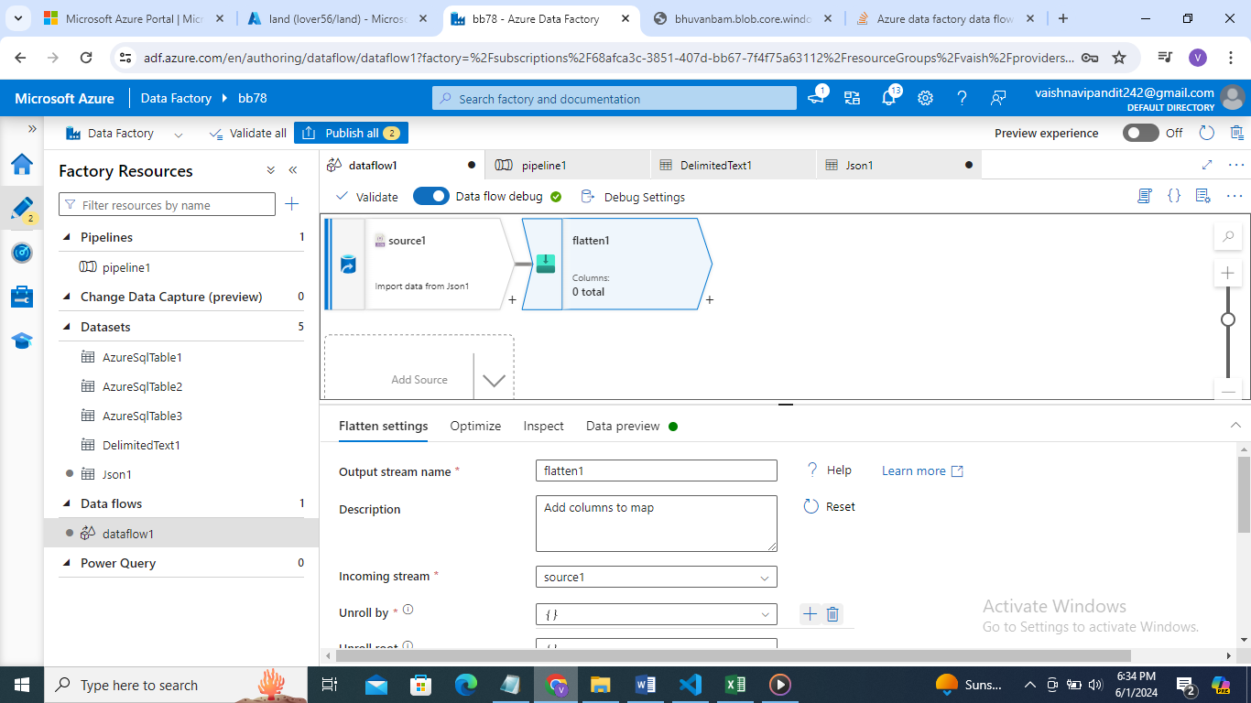

1. Go to flattern->unroll by select languages

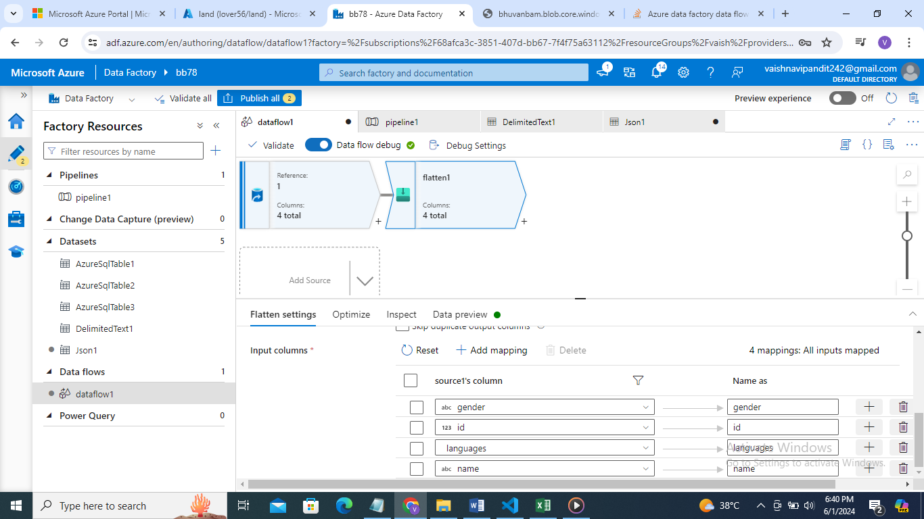

1. See preview

